# DC-4E/GEDC-6E/AHRS-8 -- Application Note 1004E

Recommended circuit for field update of firmware and World Magnetic Model for the Sparton DC-4E/GEDC-6E/AHRS-8 inertial sensors.

# Introduction

This application note describes a sample circuit, connector and connector layout to allow the DC-4E/GEDC-6E/AHRS-8 to be able to accept a field firmware upgrade. This circuit also allows the sensor to accept an update of the World Magnetic Model used to compute True North heading. It is recommended that the end user design this circuit into the product if the DC-4E/GEDC-6E/AHRS-8 will be soldered in to the user’s end application.

# Background

The DC-4E/GEDC-6E/AHRS-8 devices have a default World Magnetic Model when shipped from the factory. This magnetic model is easily updated with a new more current model provided the correct signal connections are made. Additionally, if the correct signals are available to a host PC, the firmware in the inertial system may be updated to take advantage of any future product or feature enhancements.

**Recommended Circuit**

The circuit and connector shown below are recommended to ensure that the sensor firmware is upgradable. The serial connections are shown on the left hand side of the drawing. Power and ground signals are not shown and should be connected according to the respective datasheet. Note that the USER_TXD signal goes to both the user equipment and the upgrade connector. The USER_RXD signal is multiplexed. When the upgrade cable is not connected, a pull-up selects the user’s signal for routing to the inertial system. When the upgrade cable is connected, the USER_RXD signal is routed to the upgrade connector. The other signals should be connected as shown. No additional signal conditioning is required on the upgrade connector signals as they are properly terminated within the sensor itself. Sparton recommends the Molex 53047-1010 connector, but the user is welcomed to design in any interface or interconnect methodology of their choosing.

The World Magnetic Model update is described in a separate application note. The field firmware update application will be available from Sparton Technical Support when new software releases become available.

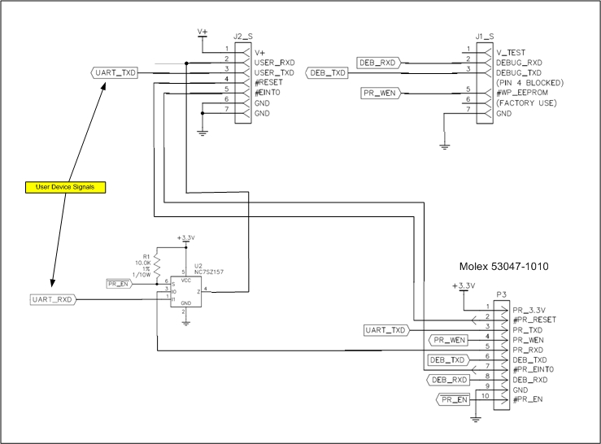

J1_S and J2_S are sensor connectors (or board pads)

***Figure 1-- Recommended Circuit and Connector***

**Want to know more?**

* Check it out here: [www.spartonnavex.com](http://www.spartonnavex.com)

Or email us at: [productsupport@sparton.com](mailto:productsupport@sparton.com)